Accessibility conformance test report
Page evaluated: registration.html
Evaluator: Vinayaka Hirematt

Summary of the conformance test
<The final WAVE conformance test was carried out after completing all required accessibility fixes. Previously report issued missing form labels, broken internal links, low-contrast elements and non-semantic interactive elements were corrected.
The updated page now conforms to WCAG 2.2 Level AA. Only one mirror contrast warning remains in the footer text, which does not count as a WCAG failure.
Overall accessibility has improved significantly.

Results of the conformance test
Note that the information you will be reporting is in your own words, but is based on the ‘Details’ and ‘Reference’ sections in your WAVE conformance test results report.
Error type: Missing from label | Example: The Full Name input field appears without an associated <label> element 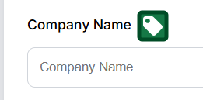 | Why is this considered to be an issue? : screen reader cannot announce what the input field is for, making the form unusable for blind users. | What should be done? : -  A <label for=”full-name”>Full Name</label> should be added and linked correctly to the inputs id so assistive technologies can identify the field. | What level of conformance does it break?: WCAG 1.3.1 Info and Relationships (Level A) and 3.3.2 labels or Instructions (Level A)
Error title: Empty button | You can take a screen snippet around the error shown in the page: An icon-only button in the top navigation had no accessible name.  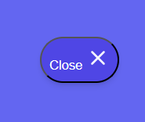 | From “Why it matters”: because buttons with no name cannot be identified or operated by screen reader users. | From “How to fix it”:  Add aria-label=”Close” or text inside the button. | From “standards and guidance”:  WCAG 4.1.2 Name, role, value (Level A)
Empty link | A decorative text <a> has no visible text or purpose  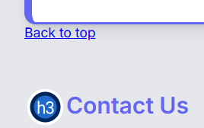 | A link with no text is announced as “link” which has no meaning and leads to confusing navigation. | Should remove link or add a meaningful descriptive text. | WCAG 2.2.4 link purpose (A)
Very low contrast | The delete button (X) used white text on a bright red background with insufficient contrast  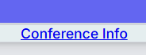 | Users with visual impairments find hard to see the text making difficult to use controls. | Darken the icon or button background | WCAG 1.4.3 contrast minimum (LEVEL A)
Orphaned from label | Some <label> tags did not reference any input for example “Company Name”  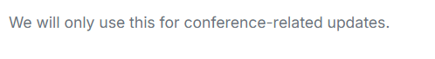 | Screen readers cannot identify which input the label describes | Add matching for=”id” to each label and unique id to each input | WCAG 1.3.1 info and Relationships (A)
Missing fieldset around group of inputs | The dietary preference radio buttons were not grouped inside a <fieldset> with a <legend> 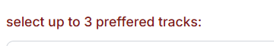 | Screen reader users cannot understand the overall question the option belongs to | Should set checkbox groups in <fieldset> <legend>Dietary Needs<\legend>….</fieldset> | WCAG 1.3.1 INFO and Relationships (A)
Skipped heading level | Page jumps from <h2> to <h4> in some sections  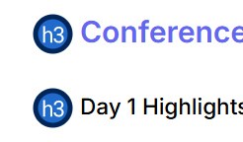 | Screen readers users rely on sequential heading structure to understand page hierarchy | Reorganize to follow a logical order h2 h3 h4 | WCAG 1.3.1 Info and Relationships (A)
Missing first-level heading (h1) | 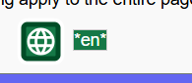 | The page did not include an <h1> | Added a main page heading:-  <h1>Conference Registration</h1> | 2.4.6 Headings and labels(AA)
Broken same-page link | 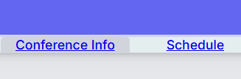 | Links pointed to ID’s that do not exist | Correct targets were added and invalid links were removed | 2.1.1 keyboard (A)
Suspicious link text | 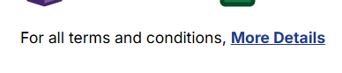 | Ambiguous text such as Click here | Links written should be descriptive such as, “View Terms and Conditions” | 2.4.4 Link Purpose(A)
Device dependent event handler | 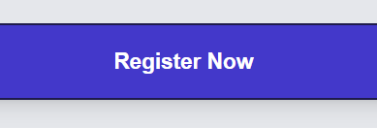 | Some actions worked with a mouse (onclick, onmouseover) | Keyboard accessible handlers such as onkeyup were added, and non-critical events removed | 2.1.1 Keyboard (A)
Accesskey | 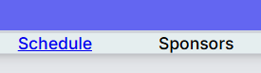 | Not required to fix | Accesskey attributes were left intentionally because they do not break WCAG rules; only an optional warning.
Tabinex | 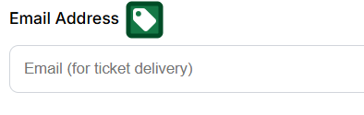 | Fixed | Removed tabindex values > 0
Justified text | 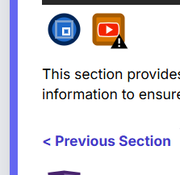 | Allowed alert | Not required for WCAG AA
Underlined non-link text | 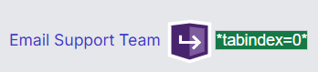 |  | Removed accidental underline styling
Layout table |  |  | Replaced with semantic HTML + CSS
Youtube video |  |  | Enables captions on the video

